**Early Learning Goals Assessments**

Dear Parents and Carers,

As part of our ongoing assessment against the 17 Early Learning Goals, we are focussing on the Technology strand. In particular, this goal can sometimes be difficult to assess purely on what we observe in school. We realise that children are often able to demonstrate their knowledge and skills more readily at home, using the technology that is a part of their everyday life.

Over the next few weeks we will be sending Home Link activities connected to Technology to help us make accurate judgements in this area. We would be very grateful if you could complete the activities with your child, making notes about anything they say, and send it back into school.

Thank you for your continued support,

The Foundation Team

**Technology : Early Learning Goal**

**Children recognise that a range of technology is used in places such as homes and schools. They select and use technology for particular purposes.**

**Name:**

**Technology : Early Learning Goal**

**Children recognise that a range of technology is used in places such as homes and schools. They select and use technology for particular purposes.**

**Can you go on a switch hunt at home?**

[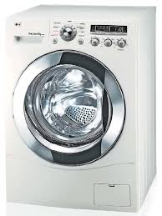](http://www.google.co.uk/imgres?sa=X&rls=com.microsoft:en-gb:IE-SearchBox&tbm=isch&tbnid=8ldmJCwF5vlfjM:&imgrefurl=http://en.wikipedia.org/wiki/Washing_machine&docid=-7TcJfTNA9LRjM&imgurl=http://upload.wikimedia.org/wikipedia/commons/0/08/LGwashingmachine.jpg&w=526&h=701&ei=KTzqUvOaBI67hAen6oHACA&zoom=1)**Here are some ideas of things you might have at home? Talk about what they do and how they work. What else can you find?**

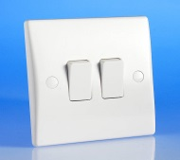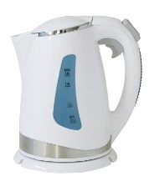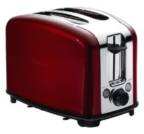

**Find objects in each room in your house. Fill in the chart below. Record through drawings and labels.**

|  |  |
| --- | --- |
| **Kitchen** | **Bedroom** |
| **Bathroom** | **Living room** |